SCNC BOARD  David Bergers  Kesara Borirak  Kevin Burkhart  Kim Clements  Dean Cutler  Andrew Epstein  Dimitri Gatsiounis  Jeff Hartwick  Charlotte Larsen  Jerry Lewis  Chip Meehan  Richard Niederberg  Laurie Rittenberg  Matt Thompson | 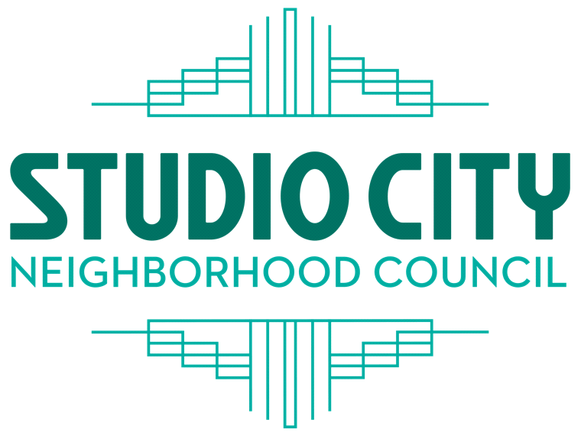  Outreach Committee Meeting  Date: January 5, 2026  Meeting starts at 7:00 PM  4024 Radford Avenue, Edit 2 Room 6 Studio City, CA 91604 (818) 655-5400  Please use RADFORD GATE (4024 Radford, just north of Ventura Blvd). Use the drive on or pedestrian access and follow instructions from Radford Security | PRESIDENT  Chip Meehan  VICE PRESIDENT  Jerry Lewis  TREASURER  David Bergers  SECRETARY  Kevin Burkhart  CORRESPONDING  SECRETARY  Dimitri Gatsiounis  studiocitync.org  
Stakeholders with disabilities who have a valid DMV placard, use a wheelchair, walker or cane, and/or those who have difficulties walking distances should notify a Radford Studio Center Security Officer or call 818-655-5085 to request shuttle assistance.

NOTE: This meeting will have a hybrid option. Protocol specifics, end of agenda.
Online: https://us02web.zoom.us/j/8986848286
Meeting ID: 898 684 8286
Dial 669-444-9171 to join the meeting
then enter meeting ID: 898 684 8286 and press #
One tap mobile: +16694449171,,8986848286# US

Committee: Charlotte Larsen (Chair, board member), Jerry Lewis (board member), Heather Lee (stakeholder), Andrew Epstein (board member), Joanna Garcia (stakeholder), Adam Silverman (stakeholder), Merci Borden (board member), Chip Meehan (President, ex officiado)

- Call to Order & Roll Call (5 min)
  - Announcement only: A reminder to those attending, during public comment you may hear colorful language that some might find offensive. The SCNC has no ability to control or regulate the content of speech that is protected under the 1st Amendment.
  - Announcement only: Please remember we are guests of Radford Studios. It is important that we remain courteous and respectful to all Radford staff we may encounter during our time on the lot. We need to respect and comply with all regulations on the lot.
  - Announcement only: Please remember that your permission to enter the private property here, is limited to access to the rooms in which we hold our meetings and any rest rooms or support facilities that exist. You are not cleared to wander the lot indiscriminately. Please do not go to areas of the facility where you have no reason to visit under your SCNC access.
- Public Comments on non-agenda items within the Board's jurisdiction, and public comment on the consent calendar (15 min, extendable by chair)
- Response to public comments (10 minutes)
- Presentation by Kidz Bazaar (Andrii Shatyrko 10 minutes)
- Social Media Report (Andrew Epstein 10 minutes)
- Swag ideas, decision and potential motion (15 minutes)
- Confirming roles and responsibilities for committee members. (5 minutes)
8. Calender events for the rest of the fiscal year (physical postings of dates onto
SCNC web/calender (10 minutes)
9. SCNC shirts prototype and discussion (5 minutes)
10. Music in the Park SCSS event (15 minutes)
11. Comments by Board members on other matters within the jurisdiction of the SCNC (10 minutes)
12. Good of the Order
13. Motion to Adjourn

Studio City Neighborhood Council Committee Meeting Agendas are posted for public review on the SCNC website at studiocitync.org and at the Radford Studio Center gate on Colfax Avenue, as well as, at the gate on Radford Avenue.
The SCNC meetings are held on an active studio lot. Due to security issues, all stakeholders will be asked to show a valid Driver’s License if you are driving a vehicle onto the lot or a valid Driver’s License or government issued Identification Card if you are walking onto the lot. An adult must accompany minors (17 years old and younger). For any security questions or concerns, please contact Radford Studio Center Security Office at 818-655-5085.
All Stakeholders are required to park in (or walk into) the studios' Sater parking structure at 4200 Radford Avenue. There are a limited number of accessible parking spaces in front of the meeting room and while there is no direct path of travel to the meeting room via a sidewalk, the studio and SCNC want to assure that Stakeholders with disabilities are able to access the meeting without difficulty. Stakeholders with disabilities who have a valid DMV placard, use a wheelchair, walker or cane, and/or those who have difficulties walking distances should contact Radford Studio Center Security Office at 818-655-5085 to request shuttle assistance at least 24 hours prior to the meeting in order for the studio to arrange services for the meeting.

PUBLIC INPUT AT NEIGHBORHOOD COUNCIL MEETINGS – The public is requested to fill out a “Speaker Card” to address the Board (or Committee) on any item from the Agenda PRIOR to the Board taking action on any item. Comments from the public on Agenda items will be heard only when the respective item is being considered. Comments from the public on other matters not appearing on the agenda that are within the Board’s (or Committee's) jurisdiction will be heard during the General Public Comment period. Please note that under the Brown Act, the Board (or Committee) is prevented from acting on a matter that you bring to its attention during the General Public Comment period; however, the issue raised by a member of the public may become the subject of a future Board (or Committee) meeting. Public comment is limited to 1 minute per speaker, unless adjusted by the presiding officer of the Board (or Committee Chair). Public comment cannot be required to be submitted in advance of the meeting, only real-time public comment is required.

THE AMERICAN WITH DISABILITIES ACT – As a covered entity under Title II of the Americans with Disabilities Act, the City of Los Angeles does not discriminate on the basis of disability and, upon request, will provide reasonable accommodation to ensure equal access to its programs, services, and activities.
Sign language interpreters, assistive listening devices, and other auxiliary aids and/or services, may be provided upon request. To ensure availability of services, please make your request at least 3 business days (72 hours) prior to the meeting you wish to attend by contacting the Department of Neighborhood Empowerment by email: NCSupport@lacity.org or phone: 213-978-1551.

NOTICE TO PAID REPRESENTATIVES – If you are compensated to monitor, attend or speak at this meeting, City law may require you to register as a lobbyist and report your activity. See Los Angeles Municipal Code Section 48.01 et seq. More information is available at ethics.lacity.org/lobbying . For assistance, please contact the Ethics Commission at 213-978-1960 or ethics.commission@lacity.org

PUBLIC ACCESS OF RECORDS – In compliance with Government Code section 54957.5, non-exempt writings that are distributed to a majority or all of the board (or committee) in advance of a meeting, may be viewed at our website: www.studiocitync.org or at the scheduled meeting. In addition, if you would like a copy of any record related to an item on the agenda, please contact the SCNC at Boardl@studiocitync.org

PUBLIC POSTING OF AGENDAS – Neighborhood Council agendas are posted for public review as follows:
- Radford Studio Center outside the Radford and Colfax gates.
- http://www.studiocitync.org
You can also receive our agendas via email by subscribing to L.A. City’s Early Notification System at http://www.lacity.org/subscriptions

Public comment must be made by the stakeholder themselves in person or on the ZOOM link during the meeting. No written communication will be read by a representative.

AB 411 specifics regarding hybrid/online meetings

IN CONFORMITY WITH THE OCTOBER 6, 2023 ENACTMENT OF CALIFORNIA SENATE BILL 411 (PORTANTINO) AND LA CITY COUNCIL APPROVAL ON NOVEMBER 1, 2023, THE STUDIO CITY NEIGHBORHOOD COUNCIL MEETING WILL BE CONDUCTED VIRTUALLY. Every person wishing to address the Committee must dial 669-444-9171, and enter 898 684 8286 and then press # to join the meeting. When prompted by the presiding officer, to provide public input at the Neighborhood Council meeting the public will be requested to dial *9 or use the Raise Hand option, to address the Committee on any agenda item before the Committee takes an action on an item. Comments from the public on agenda items will be heard only when the respective item is being considered. Comments from the public on other matters not appearing on the agenda that are within the Committee’s jurisdiction will be heard during the General Public Comment period. Please note that under the Brown Act, the Committee is prevented from acting on a matter that you bring to its attention during the General Public Comment period; however, the issue raised by a member of the public may become the subject of a future Board meeting. Public comment is limited to 2 minutes per speaker, unless adjusted by the presiding officer of the Board. SB 411 Updates: In the event of a disruption that prevents the eligible legislative body from broadcasting the meeting to members of the public using the call-in option or internet-based service option, or in the event of a disruption within the eligible legislative body’s control that prevents members of the public from offering public comments using the call-in option or internet-based service option, the eligible legislative body shall take no further action on items appearing on the meeting agenda until public access to the meeting via the call-in option or internet-based service option is restored. Actions taken on agenda items during a disruption that prevents the eligible legislative body from broadcasting the meeting may be challenged pursuant to Section 54960.1. (C) The eligible legislative body shall not require public comments to be submitted in advance of the meeting and shall provide an opportunity for the public to address the legislative body and offer comments in real time. (D) Notwithstanding Section 54953.3, an individual desiring to provide public comment through the use of an internet website, or other online platform, not under the control of the eligible legislative body, that requires registration to log in to a teleconference may be required to register as required by the third-party internet website or online platform to participate. (E) (i) An eligible legislative body that provides a timed public comment period for each agenda item shall not close the public comment period for the agenda item, or the opportunity to register, pursuant to subparagraph (D), to provide public comment until that timed public comment period has elapsed. (ii) An eligible legislative body that does not provide a timed public comment period, but takes public comment separately on each agenda item, shall allow a reasonable amount of time per agenda item to allow public members the opportunity to provide public comment, including time for members of the public to register pursuant to subparagraph (D), or otherwise be recognized for the purpose of providing public comment. (iii) An eligible legislative body that provides a timed general public comment period that does not correspond to a specific agenda item shall not close the public comment period or the opportunity to register, pursuant to subparagraph (D), until the timed general public comment period has elapsed.

Radford Studio Center
Audience Shows & Events Policies

To attend an audience, show, event, or public meeting at Radford Studio Center, the following items are required:

- Valid Government issued Driver’s license if you are driving a vehicle onto the lot.
- Valid Government issued Identification card if you are walking onto the lot. A Military ID and Passport ID will suffice.
- An adult must accompany minors (17 years old and younger). Student ID cards are preferred for those who have them.

The following items are prohibited on your person while attending an audience show, event, or public meeting on Radford Studio Center property:

- Knives
- Mace/pepper Spray
- Sharp Objects
- Firearms
- Alcoholic beverages
- Drugs (including marijuana for medicinal purposes)

All guests are subject to security screening and search. Guests will be required to pass through a metal detector or screened using a hand-held metal detector.
- Once the audience member has emptied their pockets and turned over any prohibited items, the audience member will be instructed to proceed through the metal detector or screened using a hand-held metal detector.
- Should the audience member activate the metal detector, the person will be asked to step to the side and will be scanned (entire body length front and backside) by the Security Officer with the hand-held metal detector.
- The audience member will not be allowed into the Studio until the Security Officer is satisfied that the individual has nothing on his/her person that constitutes a danger to others.
- Should the guest refuse to be screened, they are subject to being denied access to Radford Studio Center property.
- NO FIREARMS OF ANY KIND ARE ALLOWED INSIDE THE STUDIO. Security Officers who detect that a guest is in possession of a firearm should notify the Security Supervisor and P.O. IMMEDIATELY.
- Off-duty Law Enforcement in possession of a firearm will be instructed to either return the weapon to their vehicle or turn it over to Security where it will be kept, UNLOADED, in a SAFE, located in the security manager’s office.
- Any props or toys that resemble weapons in any way are to be denied or confiscated. This includes props / accompanying costumes.
Each guest/audience member will be required to submit a form of identification which will be tagged with an item that is confiscated and held with security. Guests and audience members will be instructed to pick up their confiscated items at the first (1st) level of the Sater parking structure near the elevators at the completion of the event. No personal pets are allowed at any time on the Studio lot.
If, at any time, an audience member or guest, wanders away from their event or meeting space, into an unauthorized area, that person is subject to immediate dismissal from the lot.

For any questions or concerns, please contact Security. Security office phone number, (818) 655-5085.

