LEGALLY REQUIRED OFFICIAL POSTING – PLEASE DO NOT REMOVE UNTIL AFTER BELOW DATE AND TIME

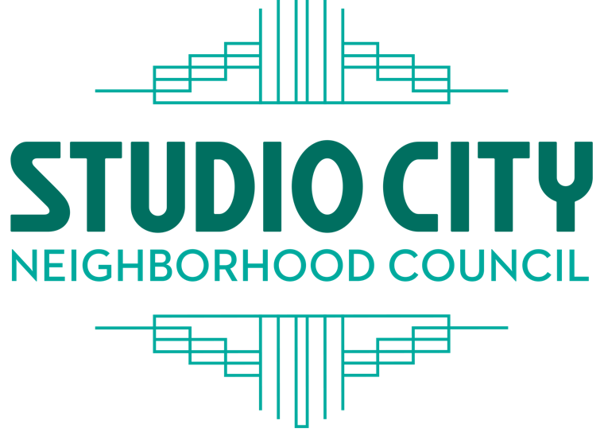
SCNC BOARD |  | PRESIDENT
Jen Bladen |  | Chip Meehan
Kevin Burkhart |  | VICE PRESIDENT
Kim Clements |  | Jerry Lewis
Dean Cutler |  | TREASURER
Dimitri Gatsiounis |  | Kim Clements
Jeff Hartwick |  | SECRETARY
Charlotte Larsen |  | Adele Slaughter
Heather Lee |  | CORRESPONDING
Jerry Lewis |  | SECRETARY
Chip Meehan |  | Jeff Hartwick
Richard Niederberg
Laurie Rittenberg
Adele Slaughter
 |  | studiocitync.org

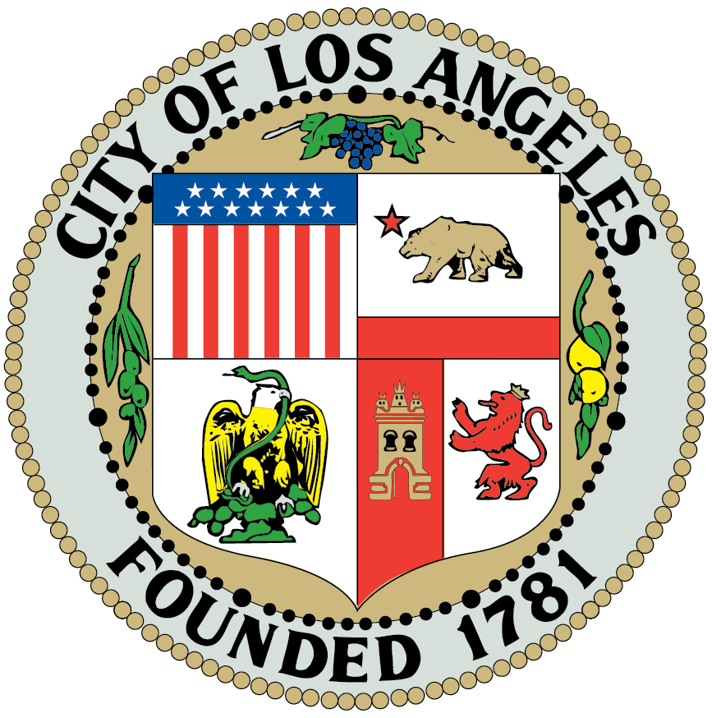

CULTURAL AFFAIRS COMMITTEE MEETING

AGENDA
August 6, 2024 @ 7:00 PM

4024 Radford Avenue, Editorial 2, Room 6
Studio City, CA 91604 (818) 655-5400

Stakeholders with disabilities who have a valid DMV placard, use a wheelchair, walker or cane, and/or those who have difficulties walking distances should notify a Radford Studio Center Security Officer or call 818-655-5085 to request shuttle assistance.

Committee Members:
Committee Members: Abi Velasco (Chair, Stakeholder), Barry Johnson (Stakeholder), Mary Mallory (Stakeholder), Brandon Morino (Stakeholder), Chip Meehan (President Ex-Officio).

1. Call to Order & Roll Call (1 min) 7:08PM
Name | Present | Absent
Abi Velasco | X
Barry Johnson | X
Mary Mallory | X
Brandon Morino | X

2. Approve minutes for May 7, 2024 (1 min).
Name | Yes | No
Abi Velasco | X
Barry Johnson | X
Mary Mallory | X
Brandon Morino | X

3. Announcement from Committee Chair. (5 mins extendable by Chair).
Happy Birthday, Barry!
Jenny Bornoff resigned in July 2024.

4. Public Comment on non-agenda items within the committee’s jurisdiction (1 min per speaker extendable by chair, 5 min maximum extendable by chair). (5 min)
None.

6. Discussion: Recapping our successful event: Movies in the Park- Summer 2024 (10 min).
Movies in the park was a huge success, we had between 150-200 stakeholders visiting the community booths and enjoyed a movie night with free snacks and refreshments.

7. Discussion and planning Mini Cultural Lecture series (20 min).
- We have received content for January, February and March 2025.
- Pending content for October & November.
- June’s lecture falls under Public Safety. This task will be forwarded to the President & Vice President.
- Despite several attempts via telephone, text messages and emails, we have not heard from the November’s presenter since June. Mary will be covering for November’s lecture.
- Cultural Affairs will support and promote lectures that fall under Cultural Affairs.
- All remaining lectures will be forwarded to the President and Vice President.
- CAC will contact the library and book session to Tuesdays instead of
8. Discussion and planning Luminaria December 2024 event (20 min).
- Luminaria tentative date: December 8th
- Mary checked on Carolers and reported they are available.
- Campo – fee waived -remove $1,700
- Add $200 compensation for MC.
9. Comments from committee members on subject matter within the committee’s jurisdiction (5 min).
None.

10. Closing comments by the Committee Chair and Vice Chair (1 min).
- Thank you so much for your time and collaboration. You and your time are very much appreciated! ☺ 11.Adjournment (1 min). Time 8:00pm

Studio City Neighborhood Council Committee Meeting Agendas are posted for public review on the SCNC website at studiocitync.org and at the Radford Studio Center gate on Colfax Avenue, as well as, at the gate on Radford Avenue.
The SCNC meetings are held on an active studio lot. Due to security issues, (just like Los Angeles City Hall), all Stakeholders are required to show a valid Driver's License if you are driving a vehicle onto the lot or a valid Driver's License or government issued Identification Card if you are walking onto the lot. An adult must accompany minors (17 years old and younger). For any security questions or concerns, please contact Radford Studio Center Security Office at 818-655-5085.
All Stakeholders are required to park in (or walk into) the studios' Sater parking structure at 4200 Radford Avenue. There are a limited number of accessible parking spaces in front of the meeting room and while there is no direct path of travel to the meeting room via a sidewalk, the studio and SCNC want to assure that Stakeholders with disabilities are able to access the meeting without difficulty. Stakeholders with disabilities who have a valid DMV placard, use a wheelchair, walker or cane, and/or those who have difficulties walking distances should contact Radford Studio Center Security Office at 818-655-5085 to request shuttle assistance at least 24 hours prior to the meeting in order for the studio to arrange services for the meeting.

PUBLIC INPUT AT NEIGHBORHOOD COUNCIL MEETINGS – The public is requested to fill out a “Speaker Card” to address the Board (or Committee) on any item from the Agenda PRIOR to the Board taking action on any item. Comments from the public on Agenda items will be heard only when the respective item is being considered. Comments from the public on other matters not appearing on the agenda that are within the Board’s (or Committee's) jurisdiction will be heard during the General Public Comment period. Please note that under the Brown Act, the Board (or Committee) is prevented from acting on a matter that you bring to its attention during the General Public Comment period; however, the issue raised by a member of the public may become the subject of a future Board (or Committee) meeting. Public comment is limited to 1 minute per speaker, unless adjusted by the presiding officer of the Board (or Committee Chair). Public comment cannot be required to be submitted in advance of the meeting, only real-time public comment is required.

THE AMERICAN WITH DISABILITIES ACT – As a covered entity under Title II of the Americans with Disabilities Act, the City of Los Angeles does not discriminate on the basis of disability and, upon request, will provide reasonable accommodation to ensure equal access to its programs, services, and activities.
Sign language interpreters, assistive listening devices, and other auxiliary aids and/or services, may be provided upon request. To ensure availability of services, please make your request at least 3 business days (72 hours) prior to the meeting you wish to attend by contacting the Department of Neighborhood Empowerment by email: NCSupport@lacity.org or phone: 213-978-1551.

NOTICE TO PAID REPRESENTATIVES – If you are compensated to monitor, attend or speak at this meeting, City law may require you to register as a lobbyist and report your activity. See Los Angeles Municipal Code Section 48.01 et seq. More information is available at ethics.lacity.org/lobbying . For assistance, please contact the Ethics Commission at 213-978-1960 or ethics.commission@lacity.org

PUBLIC ACCESS OF RECORDS – In compliance with Government Code section 54957.5, non-exempt writings that are distributed to a majority or all of the board (or committee) in advance of a meeting, may be viewed at our website: www.studiocitync.org or at the scheduled meeting. In addition, if you would like a copy of any record related to an item on the agenda, please contact President Chip Meehan at cmeehan@studiocitync.org

PUBLIC POSTING OF AGENDAS – Neighborhood Council agendas are posted for public review as follows:
- Radford Studio Center outside the Radford and Colfax gates.
- http://www.studiocitync.org
- You can also receive our agendas via email by subscribing to L.A. City’s Early Notification System at http://www.lacity.org/subscriptions
Radford Studio Center Audience Shows and Events Policies

To attend an audience, show, event, or public meeting at Radford Studio Center, the following items are required:

  - Valid Government issued Driver’s license if you are driving a vehicle onto the lot.
  - Valid Government issued Identification card if you are walking onto the lot. A Military ID and Passport ID will suffice.
  - An adult must accompany minors (17 years old and younger). Student ID cards are preferred for those who have them.

The following items are prohibited on your person while attending an audience show, event, or public meeting on Radford Studio Center property:

  - Knives
  - Mace/pepper Spray
  - Sharp Objects
  - Firearms
  - Alcoholic beverages
  - Drugs (including marijuana for medicinal purposes)

All guests are subject to security screening and search. Guests will be required to pass through a metal detector or screened using a hand-held metal detector.

  - Once the audience member has emptied their pockets and turned over any prohibited items, the audience member will be instructed to proceed through the metal detector or screened using a hand-held metal detector.
  - Should the audience member activate the metal detector, the person will be asked to step to the side and will be scanned (entire body length front and backside) by the Security Officer with the hand-held metal detector.
  - The audience member will not be allowed into the Studio until the Security Officer is satisfied that the individual has nothing on his/her person that constitutes a danger to others.
  - Should the guest refuse to be screened, they are subject to being denied access to Radford Studio Center property.
  - NO FIREARMS OF ANY KIND ARE ALLOWED INSIDE THE STUDIO. Security Officers who detect that a guest is in possession of a firearm should notify the Security Supervisor and P.O. IMMEDIATELY.
  - Off-duty Law Enforcement in possession of a firearm will be instructed to either return the weapon to their vehicle or turn it over to Security where it will be kept, UNLOADED, in a SAFE, located in the security manager’s office.
  - Any props or toys that resemble weapons in any way are to be denied or confiscated. This includes props / accompanying costumes.
Each guest/audience member will be required to submit a form of identification which will be tagged with an item that is confiscated and held with security. Guests and audience members will be instructed to pick up their confiscated items at the first (1st) level of the Sater parking structure near the elevators at the completion of the event. No personal pets are allowed at any time on the Studio lot.

If, at any time, an audience member or guest, wanders away from their event or meeting space, into an unauthorized area, that person is subject to immediate dismissal from the lot.
For any questions or concerns, please contact Security. Security office phone number, (818) 655-5085.

